1. What is a Controller?
A Controller receives HTTP requests.
Example:
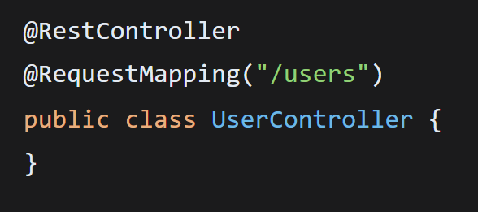
Think of it as:
Browser ➔ Controller ➔ Service
Controller should not contain business logic. It only receives requests and returns responses.

2. @RestController
Meaning: This class contains REST APIs.
Without it: Spring ignores the class.
Example:
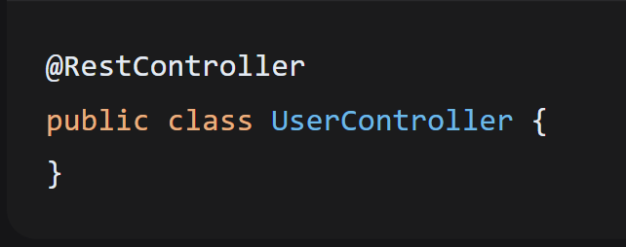
3. @RequestMapping
Sets the base URL.
Example:
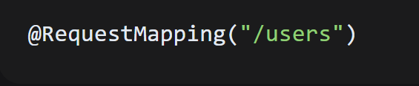
All methods inside start with /users

4. @GetMapping
Creates GET /users
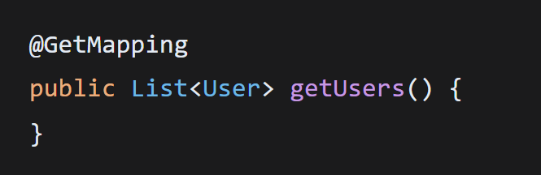
5. @PostMapping
Creates POST /users
Example:
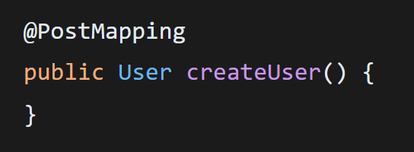
6. @PutMapping
Creates PUT /users/5
Example:
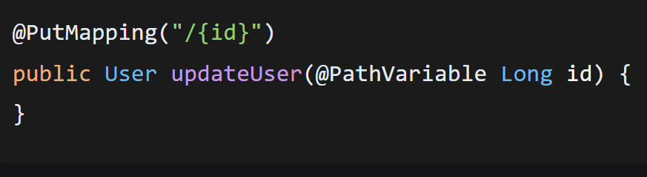
7. @DeleteMapping
Creates DELETE /users/5
Example:
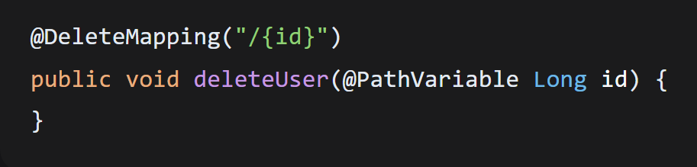
8. Path Variables
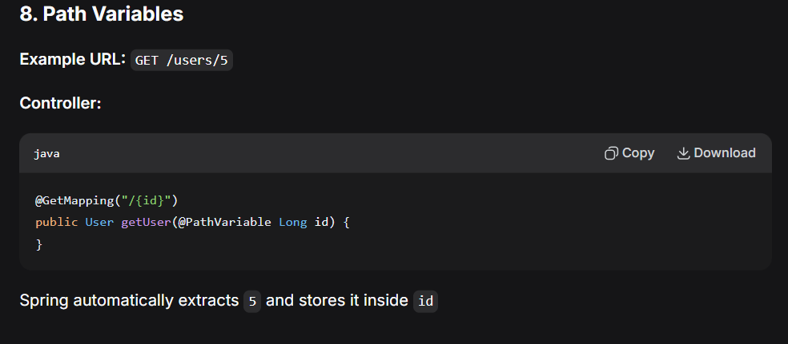

9. Request Body
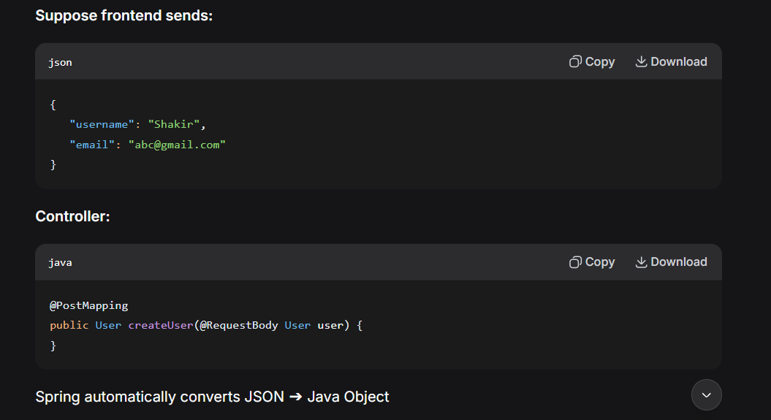
10. Query Parameters
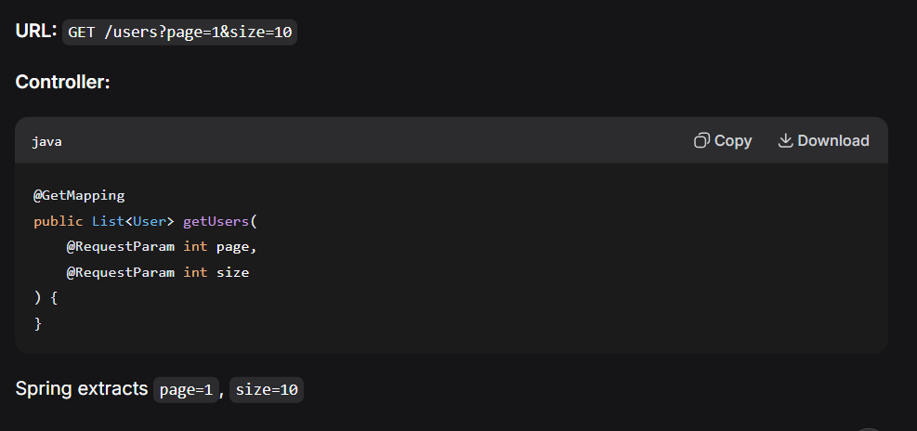

11. ResponseEntity
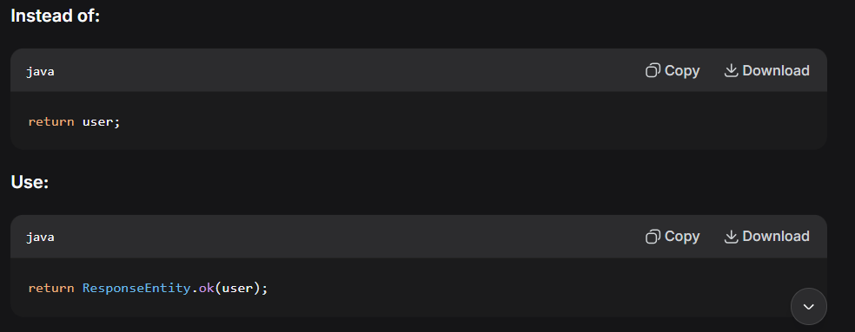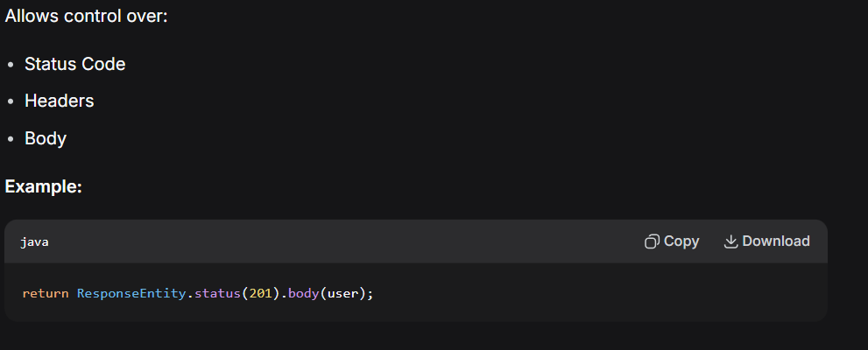
12. Request Flow
Suppose browser calls: GET /users
Browser ➔ Spring Boot ➔ Security Filter ➔ UserController ➔ UserService ➔ UserRepository ➔ Hibernate ➔ PostgreSQL ➔ Hibernate ➔ Repository ➔ Service ➔ Controller ➔ JSON Response ➔ Browser

13. Layered Architecture
Controller ➔ Service ➔ Repository ➔ Database
Layer | Responsibility | Example
Controller | Receives requests | @GetMapping
Service | Business logic | userService.getUsers()
Repository | Database access | userRepository.findAll()

14. Why Separate Layers?
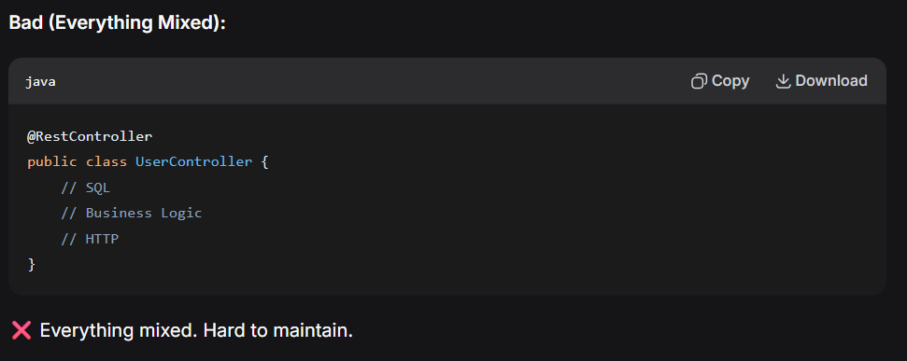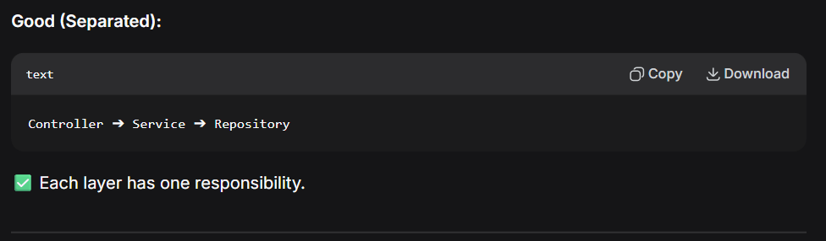
15. Example Project — GET /users
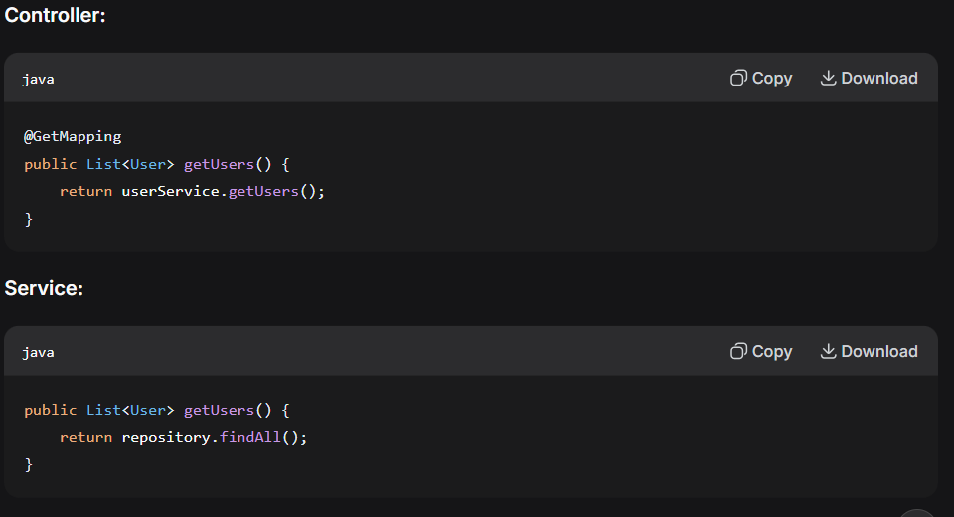

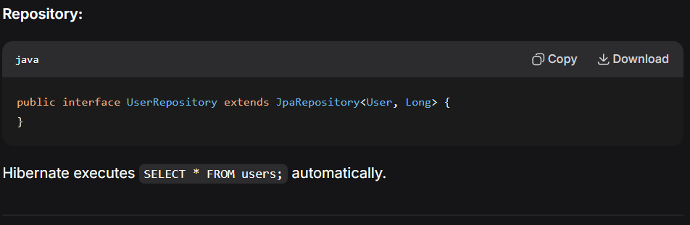

16. Request Lifecycle (Full Flow)
Client ➔ HTTP Request ➔ Tomcat ➔ Spring DispatcherServlet ➔ Security Filter ➔ Controller ➔ Service ➔ Repository ➔ Hibernate ➔ Database ➔ Hibernate ➔ Repository ➔ Service ➔ Controller ➔ JSON ➔ HTTP Response ➔ Client

17. Common HTTP Status Codes
Code | Meaning
200 | Success
201 | Created
204 | No Content
400 | Bad Request
401 | Unauthorized
403 | Forbidden
404 | Not Found
500 | Internal Server Error

18. Best Practices
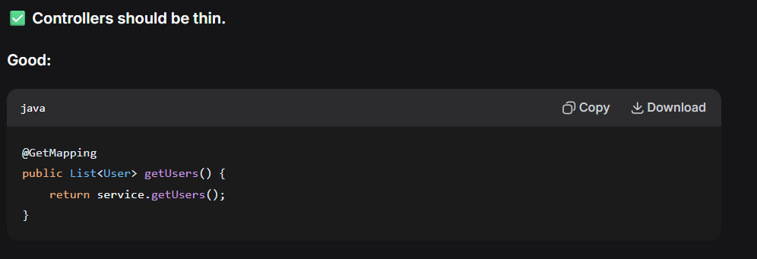
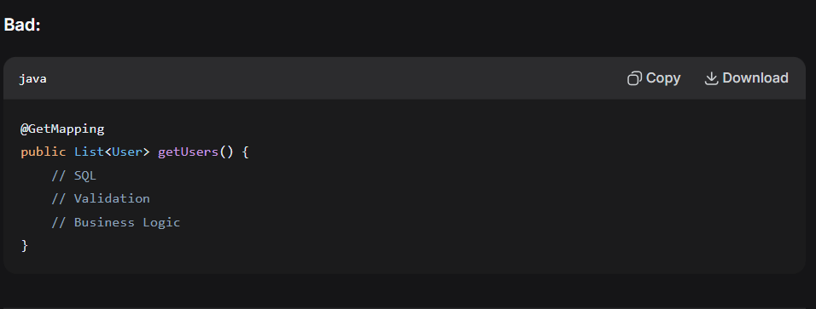
19. Interview Questions
Question | Answer
What is REST? | A style of designing HTTP APIs.
Difference between GET and POST? | GET retrieves. POST creates.
What is JSON? | A lightweight data exchange format.
What is @RestController? | Marks a class as a REST controller that handles HTTP requests and returns data (typically JSON).
Why use Service Layer? | To separate business logic from controllers.
Why use Repository Layer? | To separate database operations from business logic.

